# RFID Gin Data Management

# Operation Manual

**Last updated**: 07/06/2018

**Version**: 1.0

**Prepared by:**

Bohn Technology Solutions, LLC

**Prepared for:**

United States Department of Agriculture, Agricultural Research Service

# Table of Contents

Software License 3

System Overview 4

System Data Flow 5

System Security 6

About this Manual 6

RFID Gin Data Management Operation 7

Using the System Summary 7

Managing Records 8

Create pickup list from modules already in system 10

Create a pickup list with a GPS location only 13

Updating Settings 14

Linking RFID Module Scan 16

Resetting the system 16

Backup and Recovery 16

Uninstall RFID Gin Data Management 17

RFID Truck Scan Operation 18

Opening a Pickup List 18

Getting Directions to a Field 18

Loading and Unloading Modules 20

Creating a Pickup List on the Truck 20

Changing the Driver 21

Deleting Pickup Lists on Truck 21

Locking Settings with a Password 22

Unlocking Settings 23

Shutting Down the System 23

Clearing Truck Data 23

Changing Data Sync Interval 24

Adjusting Reader Settings 24

Uninstall the truck system 24

# Software License

*RFID Gin Data Management*, *RFID Truck Scan*, and *RFID Module Scan* and all associated documentation files, collectively the “Software”, are licensed under the following MIT license.

### The MIT License (MIT)

Copyright (c) 2018 United States Department of Agriculture, Agricultural Research Service

Permission is hereby granted, free of charge, to any person obtaining a copy of this software and associated documentation files (the "Software"), to deal in the Software without restriction, including without limitation the rights to use, copy, modify, merge, publish, distribute, sublicense, and/or sell copies of the Software, and to permit persons to whom the Software is furnished to do so, subject to the following conditions:

The above copyright notice and this permission notice shall be included in all copies or substantial portions of the Software.

THE SOFTWARE IS PROVIDED "AS IS", WITHOUT WARRANTY OF ANY KIND, EXPRESS OR IMPLIED, INCLUDING BUT NOT LIMITED TO THE WARRANTIES OF MERCHANTABILITY, FITNESS FOR A PARTICULAR PURPOSE AND NONINFRINGEMENT. IN NO EVENT SHALL THE AUTHORS OR COPYRIGHT HOLDERS BE LIABLE FOR ANY CLAIM, DAMAGES OR OTHER LIABILITY, WHETHER IN AN ACTION OF CONTRACT, TORT OR OTHERWISE, ARISING FROM, OUT OF OR IN CONNECTION WITH THE SOFTWARE OR THE USE OR OTHER DEALINGS IN THE SOFTWARE.

# System Overview

The *RFID Gin Data Management*, *RFID Truck Scan*, and *RFID Module Scan* application provide tooling for tracking cotton module inventory from the field to the gin feeder. A high-level understanding of how these applications work together is helpful when operating the system end-to-end.

The *RFID Gin Data Management* application acts as the central database for the system. This application uses a local SQL express database to aggregate and store data. It writes data such as pickup lists, client lists, farm lists, and field lists to a cloud hosted Microsoft Azure Cosmos DB. Only a subset of data is written to the cloud database, and each truck only downloads pickup lists assigned to it. This minimizes the amount of data sent over the wire. *RFID Gin Data Management* also reads new records posted to the cloud database by trucks and imports them into its local database. This incoming data is checked to prevent duplicate records as well as to maintain proper data integrity of linked records. Every few minutes *RFID Gin Data Management* syncs its data with the cloud database.

*RFID Truck Scan* collects data for each load/unload event and writes this data to the cloud database which the *RFID Gin Data Management* app downloads and processes to update the central SQL database. Like the gin software, the truck software syncs with the cloud database at regular intervals when a network connection is available. This sync processes records added, updated, or removed by the gin software and writes new records that were created by the truck.

*RFID Module Scan* is an Android application capable of scanning modules optically or using a Blue Tooth connected TSL scanner. It can be used to scan modules in the field into a load list and transmit that list to the gin by sending the load list to a gin email address. The gin software can be configured to import files from this email address at regular intervals. When running in GIN mode, *RFID Module Scan* has read access to cloud database giving it the ability to pull in client, farm, and field lists created at the gin.

# System Data Flow

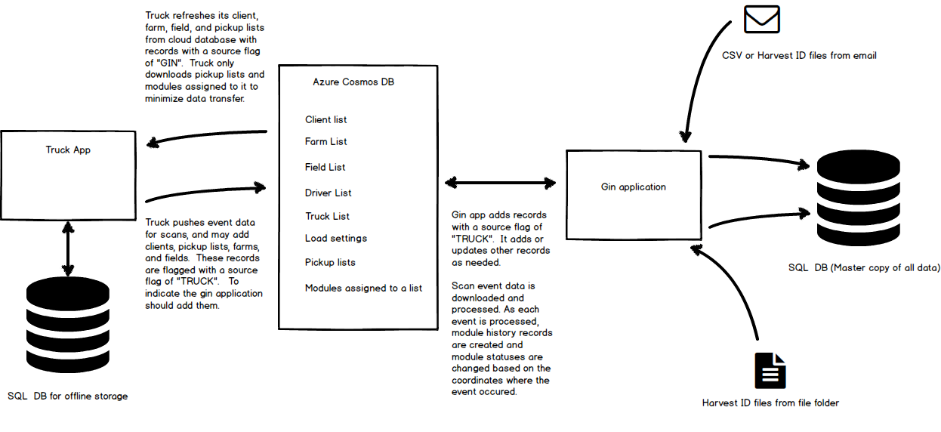

# System Security

All data sent to or received from the Microsoft Azure Cosmos database in the cloud is performed over an SSL connection to encrypt the data going over the wire. Access to the Cosmos database is controlled by the Read/Write keys or Read Only keys provided by Microsoft. It is important that these keys be safe guarded and only shared on an as-needed basis.

On the truck system, a system administrator may set a password to lock sensitive settings so that truck operators cannot view or modify the Cosmos database keys.

When the Android app is connected using gin mode, it is given a read only key to the Azure Cosmos database. This key is embedded in a QR code. This code should only be given out to users that you trust with read access to your data.

# About this Manual

This manual uses a task focused approach. Each section illustrates how to complete a specific task with the aid of screen captures and annotations.

# RFID Gin Data Management Operation

## Using the System Summary

This system summary screen summarizes module counts based on location, as well as the status of data imports and syncing. See the following for the tasks each button performs.

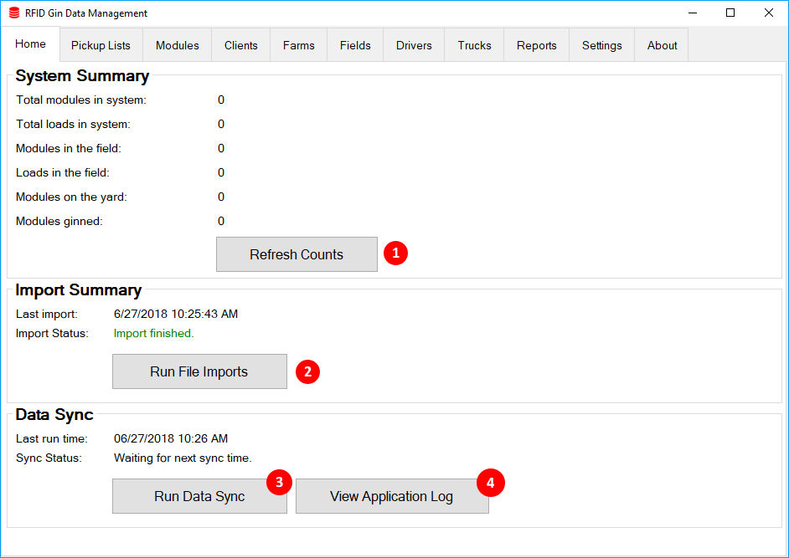

### Refresh Counts

Click this button to ensure counts are up to date. The system continually updates data in the background, so the counts may become stale.

### Run File Imports

This button forces file imports to run. File imports include looking for new files in the Import Folder (this location is saved in the *Settings* tab.) If an email account has been connected, then files are also imported from email.

### Run Data Sync

This button forces the data sync to run. This will ensure any records added or changed at the gin are written out to the cloud. It also pulls in any data added by trucks since the last sync.

### View Application Log

This button opens a text file that contains diagnostic information.

## Managing Records

Records for pickup lists, modules, clients, farms, fields, trucks, and drivers are all managed in a similar fashion. This section will use the *Fields* tab as an example, but records in other tabs are managed the same way.

### Add a New Record

To add a new record, click the *Add* button at the bottom of the screen.

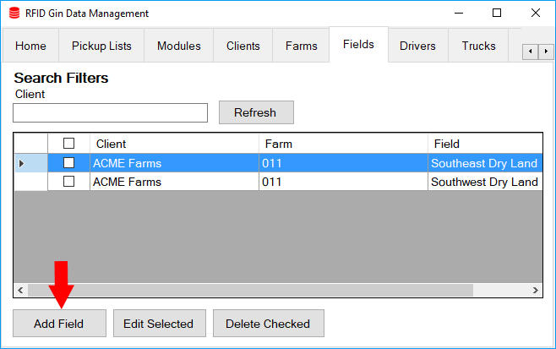

### Update a Record

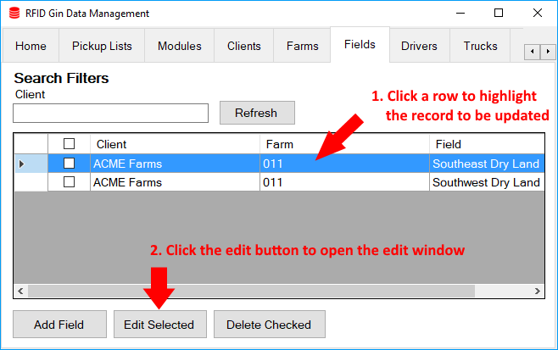

### Deleting records

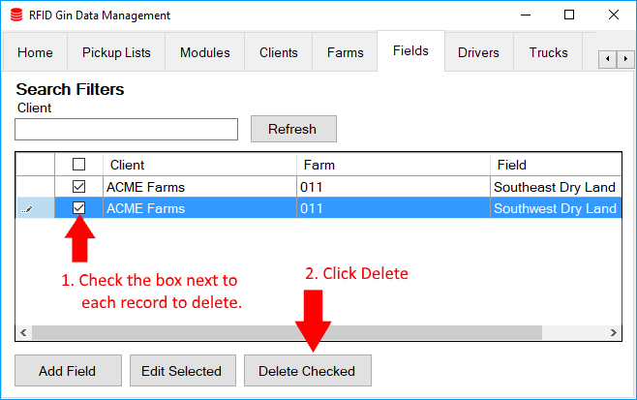

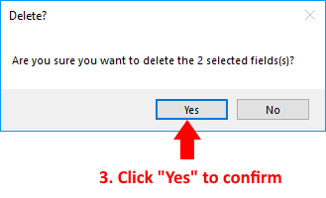

## Create pickup list from modules already in system

## 

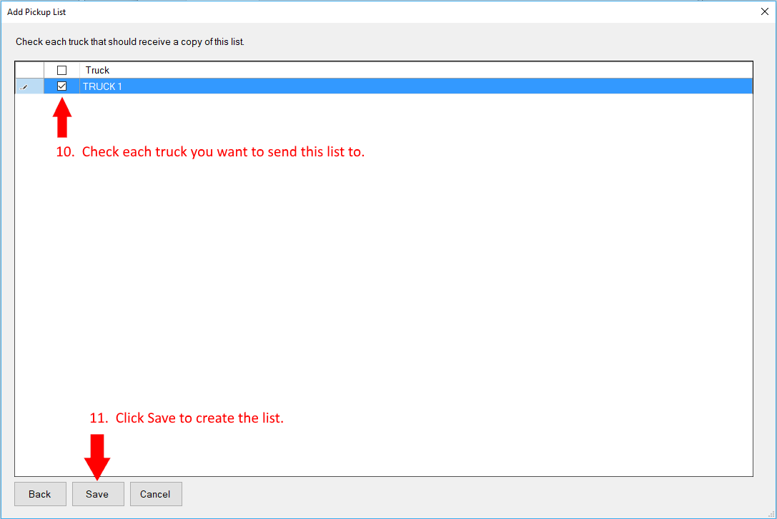

Once your list is saved, it should appear in the grid on the *Pickup Lists* tab. As modules are hauled the associated summary counts will be updated. When all modules on the list have been moved to the target destination, the list status will be COMPLETE. You may need to click the *Refresh* button from time to time to ensure the *Pickup List* tab is refreshed with latest statuses.

## Create a pickup list with a GPS location only

Go to the *Pickup Lists* tab and click the *Add List* button.

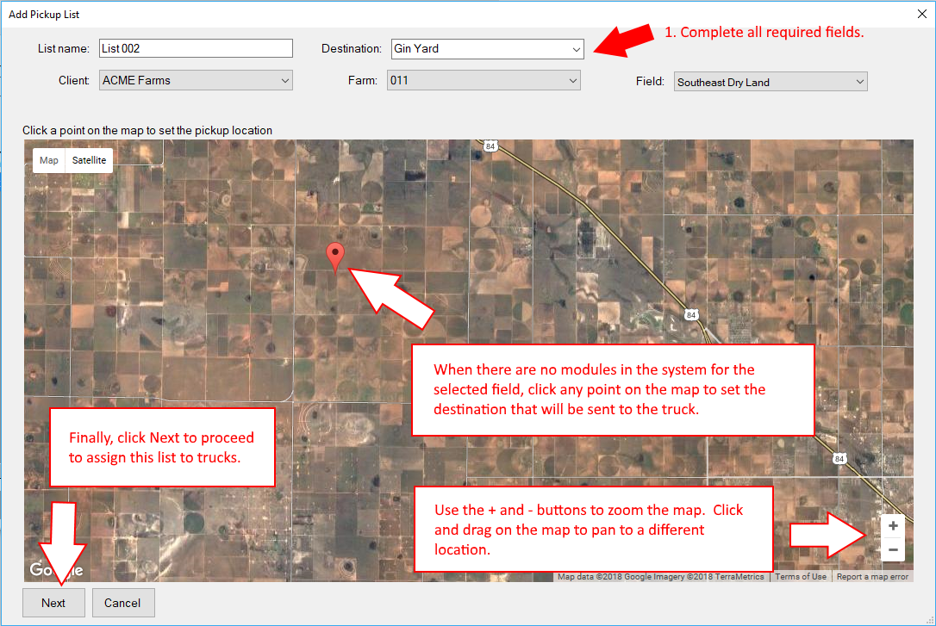

## Updating Settings

All system settings in the *RFID Gin Data Management* application are managed on the *Settings* tab. **After modifying a setting, you must click the *Save* button to apply the settings.** The tables below describe the purpose of each setting.

|  |  |
| --- | --- |
| Folder Settings | |
| Import files from folder | This folder will be monitored for new or updated files. When changes are detected, the affected files will be imported. The system will attempt to import CSV and HID format files. Files from email get downloaded into an *EmailImports* folder inside of this folder. |
| Pickup list archive folder | Every time a pickup list is saved, a CSV version of the list is written to this folder. |

|  |  |
| --- | --- |
| IMAP Import – The login for an email account that will receive files from RFID Module Scan | |
| Hostname | This is the hostname of your email provider. Here are hostnames for several popular providers:   * imap.outlook.com * imap.mail.yahoo.com * imap.gmail.com |
| Port | This is the port number your provider uses for the IMAP protocol. Most providers use port 993, but your provider might use a different port |
| Username | This is the username used to login to your email. This is usually your email address. |
| Password | The password for your email account. Your password is saved on the gin computer, but it is not stored anywhere else. |

|  |  |
| --- | --- |
| Geocoding – These settings are used to define drop zones that will trigger module status changes | |
| Gin Yard NW Corner | The latitude and longitude of the northwest corner of your gin yard in decimal degrees. |
| Gin Yard SE Corner | The latitude and longitude of the southeast corner of your gin yard in decimal degrees. Together with the northwest corner coordinates, these coordinates define a rectangle where module inventory is stored while waiting to be ginned. When an unload event happens in this rectangle, the status of unloaded modules will be changed to “AT YARD”. |
| Feeder coordinates | The latitude and longitude of the point where modules are dropped at the feeder. |
| Feeder detection radius | The distance in yards which specifies a circular radius. When modules are dropped inside this radius, their status will be changed to “GINNED”. |

|  |  |
| --- | --- |
| Import Schedule | |
| Run Every x Minutes | This setting determines how frequently files are imported from email and the import folder. This setting does not control frequency of the cloud database sync. |

|  |  |
| --- | --- |
| Azure Cosmos Read/Write Keys | |
| Read/Write URI | The URI endpoint for read/write access |
| Key | The key for read/write access. Note that anyone obtaining this key has full access to your Microsoft Azure Cosmos DB. |

|  |  |
| --- | --- |
| Azure Cosmos Read-only Keys | |
| Read Only URI | The URI endpoint for read-only access |
| Key | The key for read only access. Note that anyone obtaining this key has access to read all data posted in your Microsoft Azure Cosmos DB. This key can be distributed via QR code to Android devices belonging to trusted users. |

|  |  |
| --- | --- |
| Gin Info / Load Numbering | |
| Load Number Prefix | A text prefix that will be used as the starting characters for all load numbers. For example, a typical use case would be to set this to the current crop year such as 2018. |
| Starting Load Number | This is the load number that all trucks will start with. |
| Module per load | The number of modules each truck can transport in a load. This is primarily used to calculate loads completed and remaining. |
| Gin Name | This is embedded in the QR code used to link *RFID Module Scan* and is displayed in the Android app when it is connected. |

## Linking RFID Module Scan

To link *RFID Module Scan*, follow these steps:

* Ensure you have the latest version *of RFID Cotton Module Scan* installed from the *Google Play Store*.
* In the *RFID Gin Data Management* application on the gin computer, go to the *Settings* tab
* In the box labeled *Azure Cosmos READ ONLY Keys* click the *Connect RFID Module Scan* button. A window should appear displaying a QR code. You need to scan this code from *RFID Module Scan*.
* Open *RFID Module Scan* on your Android device and go to *Settings*
* Scroll to the bottom of the *Settings* screen and tap *Connect to Gin*
* A camera view will open. Hold your device up to the 2D bar code to scan it.
* The camera view will automatically close, and you should see *Connected to: [your gin name]* at the bottom of the Android app settings screen.

## Resetting the system

The system can be reset to clear out all module data. To reset the system, it is recommended that you perform these steps.

* Ensure all modules are unloaded and clear all data on trucks. This clears data held on the trucks.
* Clear all module data in *RFID Gin Data Management* running on the gin computer by going to *Settings* and clicking the *Clear Module Data* button. This will delete all pickup lists and modules from the gin computer database and will also remove all data in the cloud database.

## Backup and Recovery

The gin application automatically writes a backup of its SQL Express database every two hours. The backup files are located in C:\Users\ *[your username]*\AppData\Roaming\CottonDBMS\GinApp\Backup. For further data protection, you can use a 3rd party backup application to copy the backup folder to another drive or cloud backup service. Below are several popular backup applications:

* Windows File History – provided with Windows 10 and can be used to backup files to external drive
* Carbonite – online service
* Acronis True Image Backup and Recovery

If you need to recover your SQL database, you must do so using a utility such as [SQL Server Management Studio](https://docs.microsoft.com/en-us/sql/ssms/download-sql-server-management-studio-ssms?view=sql-server-2017). The recommended approach to restoring the system is as follows:

* Clear data on all truck systems.
* If possible, go to the *Settings* tab in *RFID Gin Data Management* and click *Clear Module Data*
* Close *RFID Gin Data Management*
* Open *SQL Server Management Studio* and connect to *(LocalDB)\MSSQLLocalDB* using your windows account.
* Expand the Databases tree in the left pane, right click on *CottonDBMS_GinDB* go to *Tasks -> Restore -> Database*.
* In the dialog that opens click the *Timeline* button
* Choose the *specific date and time* option
* Use the slider to set the restore point you want to go back to and click *Ok*
* Click *Ok* in the *Restore Database* window
* Re-sync the gin and truck systems

## Uninstall RFID Gin Data Management

You may uninstall the software by following the following steps:

1. It is recommended to remove the software from all trucks first.
2. Close *RFID Gin Data Management* if it is open
3. Go to *Add or Remove Programs* in Windows and search for *RFID Gin Data Management*
4. Click *Uninstall*
5. The uninstall package will delete all data and data cannot be recovered. Module data stored on the gin computer will be deleted and the Azure Cosmos cloud database will be emptied.

# RFID Truck Scan Operation

## Opening a Pickup List

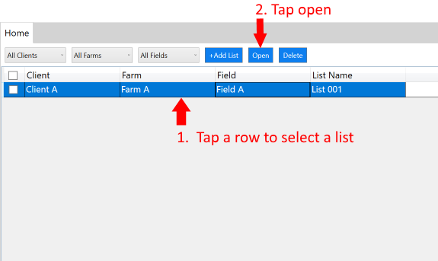

## Getting Directions to a Field

From the *Home* tab, tap a list to select it, then click *Open.* A map will open showing load information and a map with module locations.

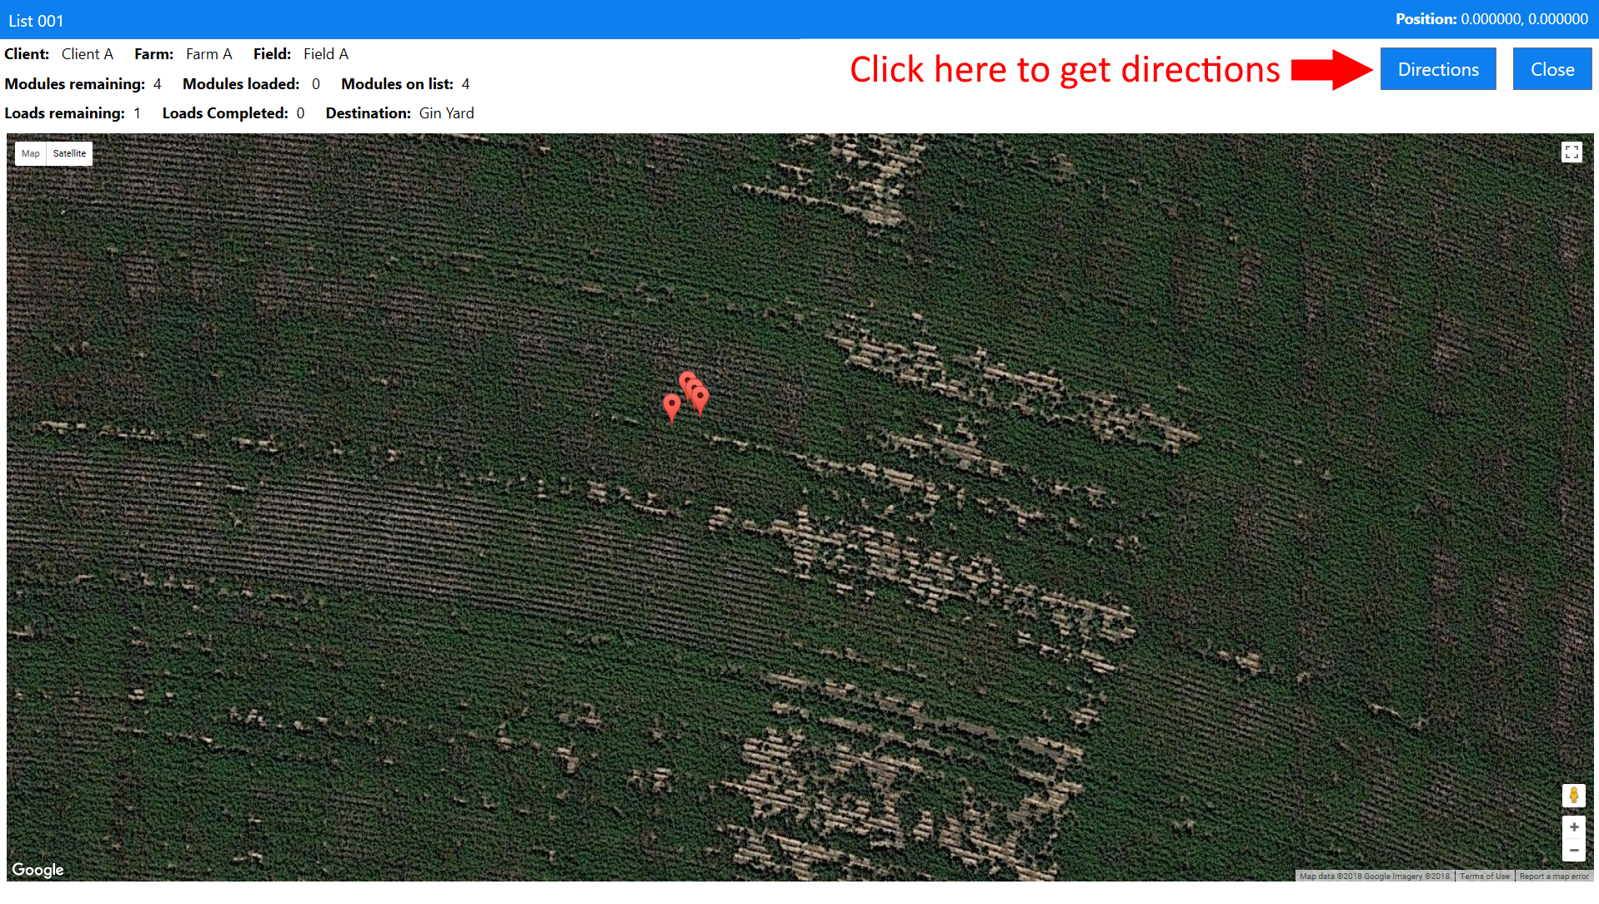

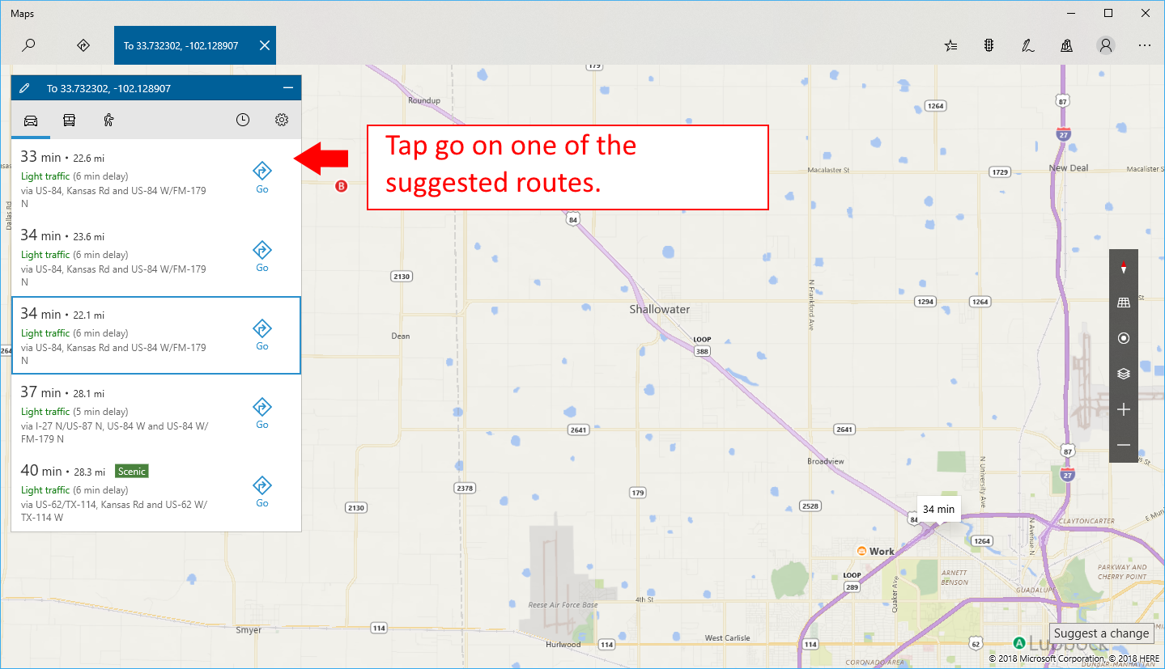

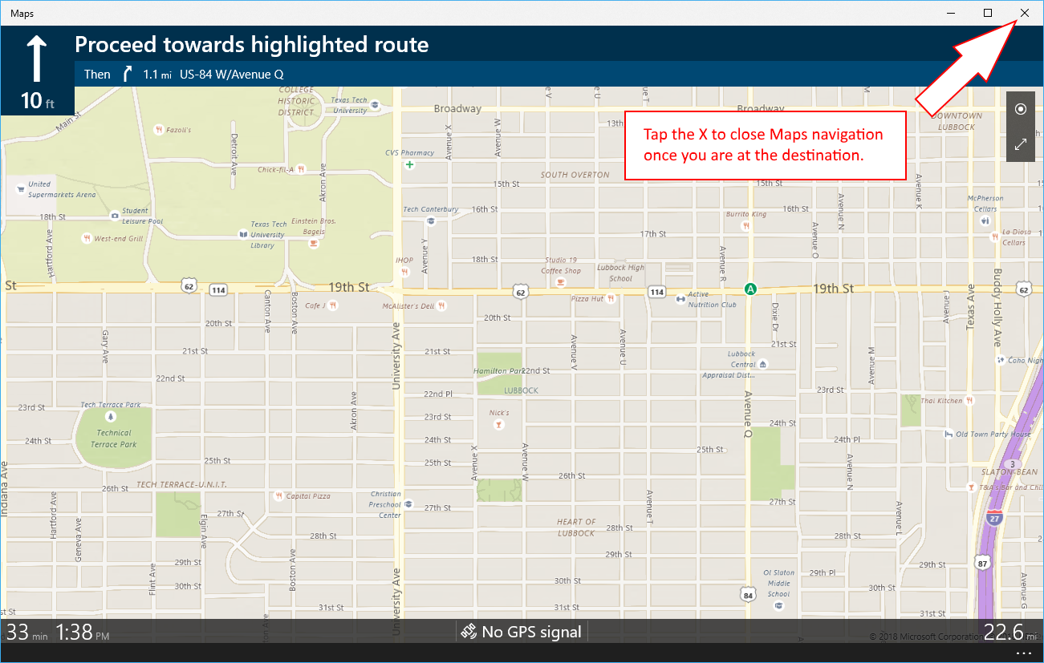

## Loading and Unloading Modules

To begin a loading sequence, you may open a pickup list from the *Home* tab and begin loading modules on a truck. Alternatively, you may also begin loading modules without opening any list. In this case, the system will try to open the matching list when the first module is scanned. As each module is scanned the serial number will be shown on the display. If a serial number is loaded that isn’t on the list, a warning will be displayed. At this point the driver must choose to unload the module or continue and select the list that all modules currently on the truck should be re-assigned to.

## Creating a Pickup List on the Truck

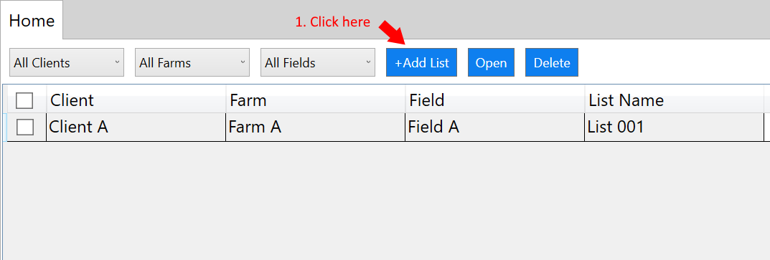

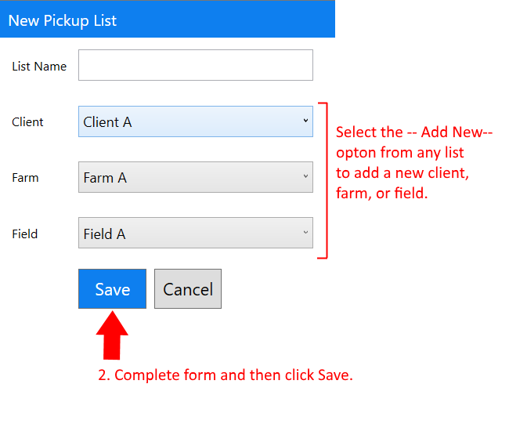

## Changing the Driver

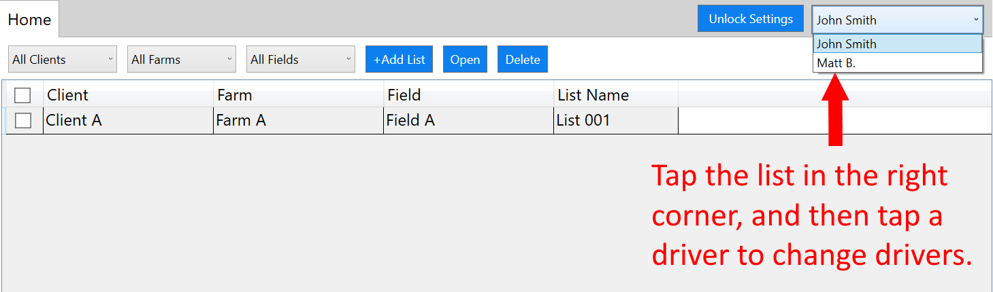

## Deleting Pickup Lists on Truck

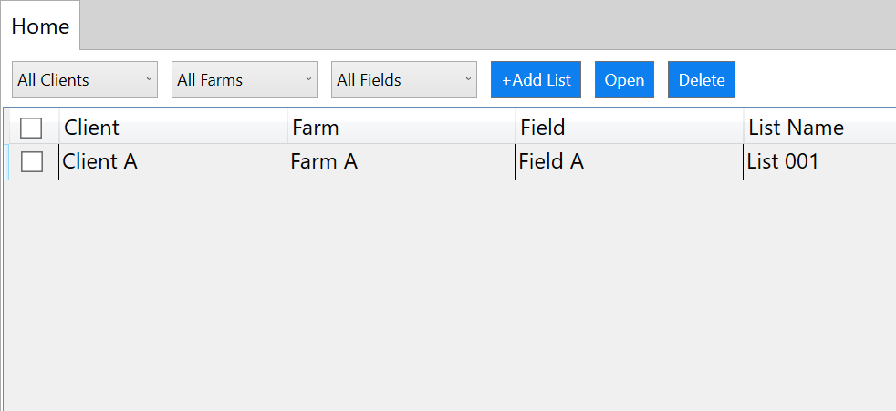

1. **Tap the *Delete* button**
2. **Check each list you want to delete.**

To delete a list the truck must have a network connection, and there should be no modules on the truck that belong to the list. Deleting a list on the truck does not remove the list from the gin database. When all trucks have deleted a list, the list will be unlocked so that the gin software can also delete the list.

## Locking Settings with a Password

You may set a system password so that the Truck ID, data sync, and reader settings can only be changed by an administrator who knows the password.

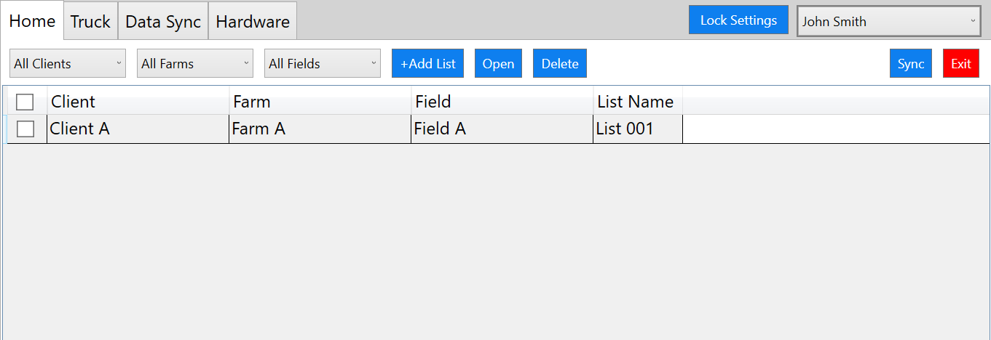

**These tabs will be hidden when settings are locked.**

1. **Tap *Lock Settings***

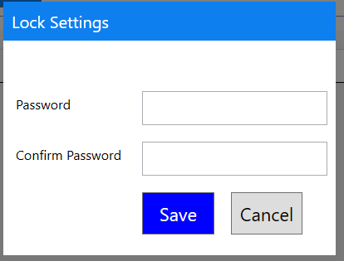

**2. Enter and confirm the password**

**3. Tap *Save***

## Unlocking Settings

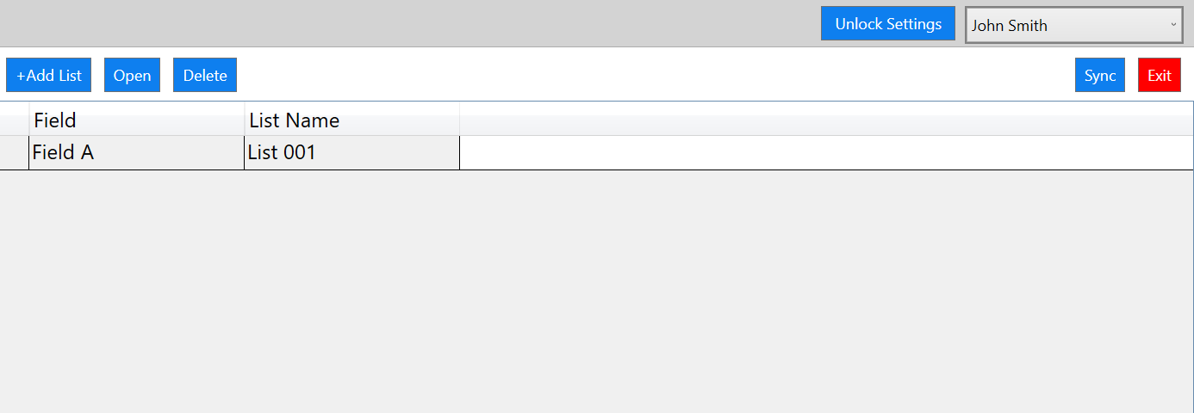

**Tap *Unlock Settings*, and then enter the system password in the box that opens.**

## Shutting Down the System

To shut down the truck system, tap the red *Exit* button displayed on the top right corner of the *Home* tab. This is the recommended method of closing the application as it disconnects the application from all hardware. Forcing the application closed by another means could leave the computer connected to the RFID reader or other hardware.

## Clearing Truck Data

On the *Data Sync* tab, you will find two buttons:

* A *Clear Module Data* button – This button will remove all modules and pickup lists this truck has downloaded from the truck computer. It will also release the lists, so they can be deleted at the gin.
* A *Clear ALL Data* button – This button clears client, farm, and field lists in addition to pickup lists and module data.

## Changing Data Sync Interval

The data sync interval specifies how frequently the truck computer syncs with the cloud database. If set to 5, the system would sync every 5 minutes.

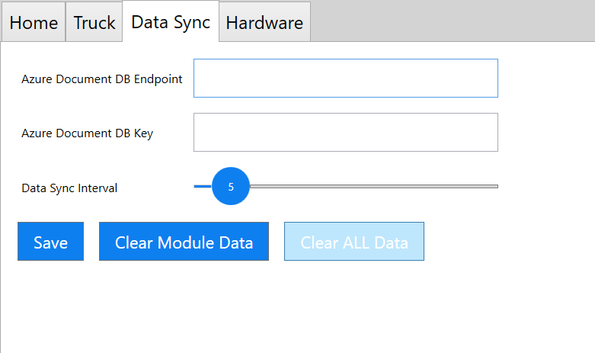

1. **Click *Save* to save changes**
2. **Slide the round circle left to sync more often and right to sync less often**

## Adjusting Reader Settings

You may adjust reader settings on the *Hardware* tab. You may adjust the transmit power and sensitivity of each antenna connected to the reader. The reader may have up to 4 antennas connected. These settings are automatically set during installation to values determined during beta testing. If you change the settings, you must hit the *Save* button to have the settings written to the RFID reader.

## Uninstall the truck system

To remove *RFID Truck Scan* from a truck computer, you should follow these steps:

1. Go to the *Data Sync* tab and tap *Clear ALL Data*. This will send all unload/load events recorded by the truck to the cloud database.
2. Close the application using the *Exit* button on the *Home* tab.
3. Go to *Add/Remove programs* and find *RFID Truck Scan* and choose to uninstall. This will remove all files and data from the truck computer.